**Unit 8 Transformations Quiz 1: Translations, Reflections, Rotations**

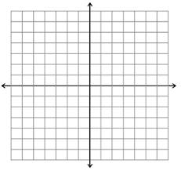(*20 points)*

1. *(5 points)* Rectangle ABCD has vertices at A(-1,-2) B(2,-2) C (2,-4) and D(-1,-4). Graph and state the coordinates of the image after *Rx*-axis(*ABCD*).

2. *(4 points)* Triangle ABC has vertices at A(1,1) B(1,-1) and C(4,-1). Graph and state the coordinates of the image after *r* (90º, *O*)(*ABC*).



3. *(4 points)* Triangle ABC has vertices at A(0,1) B(3,3) and C(3,-2). Graph and state the coordinates of the image after *T*<-3, 1>(Δ*ABC*)



1. 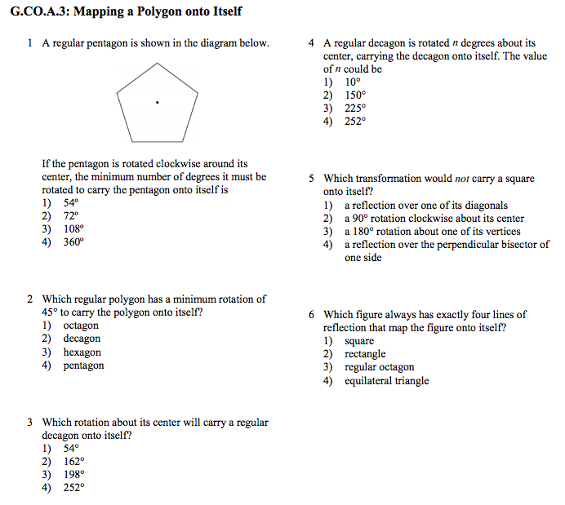 *(2 points)* **5.** *(2 points)*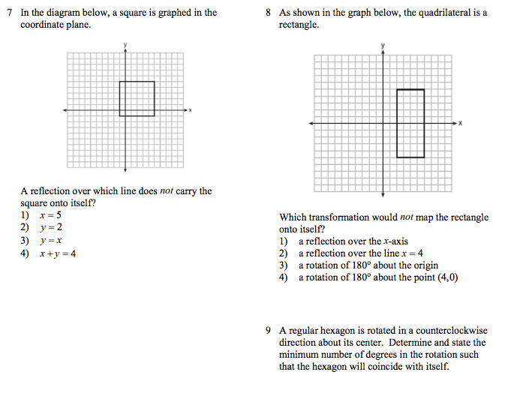

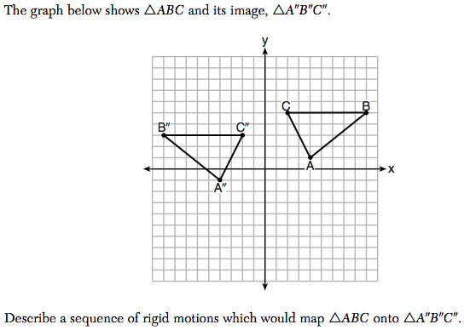**6.** *(3 points)*

**EXTRA CREDIT!** *For 2 extra points.*Graph the line of reflection and write the equation of the line of reflection.

